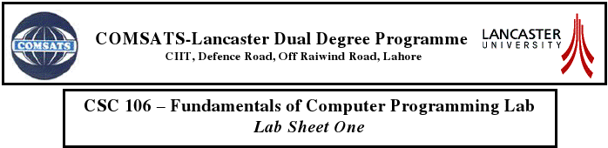

**ASSIGNMENT:LAB SHEET 3**

***Waqas Ashiq.***

***Bcs-f11-201.***

***Section c.***

***Submitted to: Sir Bilal Hassan.***

***EXERCISE: 1***

***/*MATH FUNCTIONS*/***

***CODE:***

#include<stdio.h>

#include<math.h>

int main()

{

double x=fabs(7.5);

printf("fabs(7.5) is :\t%.2lf\n",x);

double y=floor(7.5);

printf("\nfloor(7.5) is :\t%.2lf\n",y);

double z=fabs(0.0);

printf("\nfabs(0.0) is :\t%.2lf\n",z);

double a=ceil(0.0);

printf("\nceil(0.0) is :\t%.2lf\n",a);

double b=fabs(-6.4);

printf("\nfabs(-6.4) is :\t%.2lf\n",b);

double c=ceil(-6.4);

printf("\nceil(-6.4) is :\t%.2lf\n",c);

double d=ceil(-fabs(-8+floor(-5.5)));

printf("\nceil(-fabs(-8+floor(-5.5))) is :\t%.2lf\n",b);

printf("\n\n\n\n");

return 0;

}

***OUTPUT:***

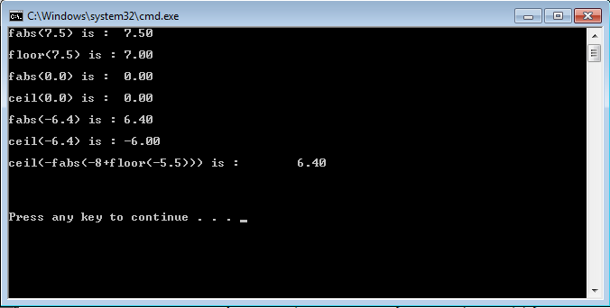

***EXERCISE: 2***

***/*HYPOTENUSE CALCULATION*/***

***CODE:***

#include<stdio.h>

#include<math.h>

double hyp(double x,double y);

int main(void)

{

double b,p;

printf("enter the value of base and prependicular:\t");

scanf("%lf%lf",&b,&p);

printf("\n\nThe hypotenouse is:\t%lf",hyp(b,p));

printf("\n\n\n");

return 0;

}

double hyp(double x,double y )

{

double h;

h=sqrt( pow(x,2) + pow(y,2) );

return h;

}

***OUTPUT:***

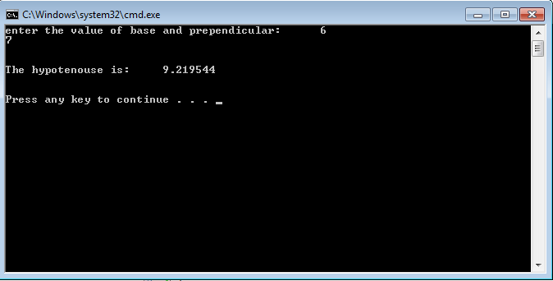

***EXERCISE:3***

***/*GREATEST COMMON DIVISIOR*/***

***CODE:***

#include<stdio.h>

int GCD (int x, int y);

int main(void)

{

int a, b;

printf("Enter the numbers:\t");

scanf("%d%d", &a,&b);

printf("\n\nGreates common divisior is: %d\n", GCD(a, b));

printf("\n\n\n");

}

int GCD(int x, int y)

{

int num;

if (x % y == 0)

return(y);

if(x < y)

{

num = y;

x = y;

x = num;

}

if(x % y != 0)

{

num = x % y;

y = x;

x = num;

}

}

***OUTPUT:***

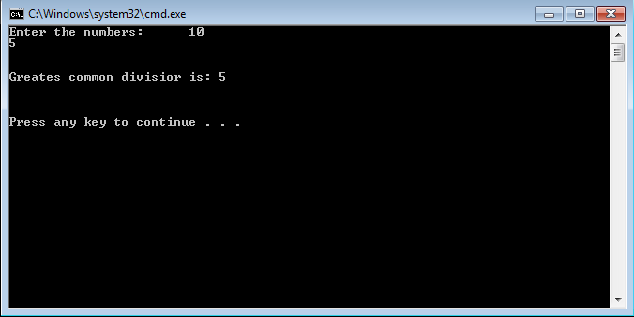

***EXERCISE:4***

***/*RANDOM NUMBER GENERATION*/***

***CODE:***

#include<stdio.h>

#include<stdlib.h>

#include<time.h>

int main(void)

{

/*random number genration*/

int X;

srand(time(NULL));

X = 1 + rand() % 3;

printf("\nRandom Number between 1 and 2:%d\n", X);

X = 1 + rand() % 101;

printf("\nRandom Number between 1 and 100:%d\n", X);

X = rand() % 10;

printf("\nRandom Number between 0 and 9:%d\n", X);

X = -1 + rand() % 2;

printf("\nRandom Number between -1 and 1:%d\n", X);

X = -3 + rand() % 12;

printf("\nRandom Number between -3 and 11:%d\n\n\n", X);

}

***OUTPUT:***

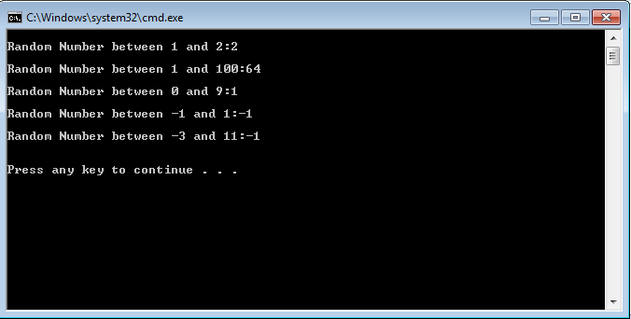

***EXERCISE:5***

***/*TOSS OF A COIN*/***

***CODE:***

#include<stdio.h>

#include<stdlib.h>

#include<time.h>

int flip(); /*function prototype*/

int X = time(NULL); /*function prototype*/

int main(void)

{

int Head=0, Tail=0;

printf("A Coin is tossed 100 Times (H = HEADS, T = TAILS): \n\n\n");

for (int y = 1; y<=100; y++)

{

int a = flip();

if (a == 0)

{

Tail++;

printf("\tT ");

}

if (a == 1)

{

Head++;

printf("\tH ");

}

}

printf("\n\n\nHeads Came %d Times\n", Head);

printf("\n\nTails Came %d Times\n\n", Tail);

}

int flip()/*function flip definition*/

{

srand(X);

int C = rand() % 2;

X++;

return (C);

}

***OUTPUT:***

